|  |  |
| --- | --- |
|  | **EXERCÍCIO DE INGLES**  **Nome:_______________________________________**  **PROFESSORA: Helga Nelken 1º ano EM** |

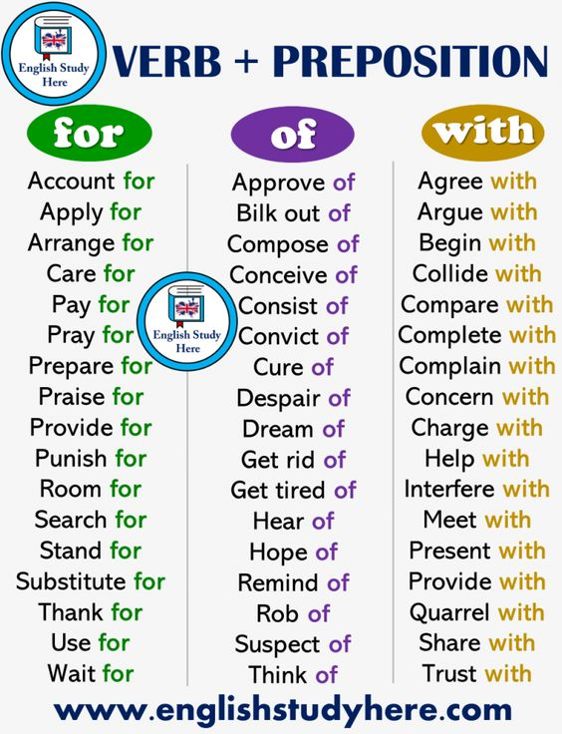

1. Read the chart and write an essay about “ What is this situation going to cause to our economy ? “. Use at least 5 of the verbs from the chart and at least 150 words.