

# Biologia

**3ª etapa – Profª: Patrícia Sommerfeld**

**1)** O esquema a seguir, representando a estrutura interna de um echinodermata:

**B**

**A**

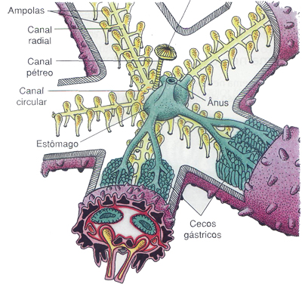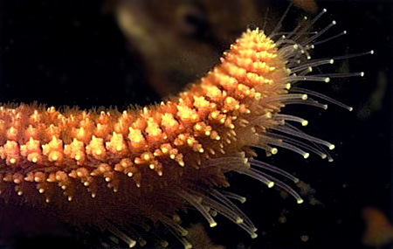

Figura 1 Figura 2

a) Qual é o animal representado?________________________________________________

b) Como se denomina a estrutura indicada pela letra **A**? _____________________________

c) Para que serve a estrutura indicada pela letra **B**?

_________________________________________________________________________________________________________________________________________________________________________________________________________________________________

d)Como se denominam as estruturas indicadas pelas setas, na figura 2?

___________________________________________________________________________

Para que servem essas estruturas?

_________________________________________________________________________________________________________________________________________________________________________________________________________________________________

**2)** Observou-se que um ouriço-do-mar sobrevivia em meio aquático com o nível da água até a metade do seu corpo, porém esse ouriço apresentava **dificuldade de movimentar-se e eliminar excretas**. Explique, detalhadamente, a razão para essas deficiências.

______________________________________________________________________________________________________________________________________________________________________________________________________________________________________________________________________________________________________________________________________________________________________________________________________________________________________________________________________________

**3)** Suponha que você encontre a seguinte notícia num jornal: “ Cientista descobre primeiro equinoderma dulcícola”. Argumente, com base nas características dos ouriços do mar, a impossibilidade de tal descoberta.

___________________________________________________________________________________________________________________________________________________________________________________________________________________________________________________________________________________________________________________________________________________________________________________________________________________________________________________________________________________________________________________________________________________________

**4)** Pensando em acabar com as estrelas-do-mar que comiam os mexilhões que criavam, alguns pescadores partiam as estrelas, separando os braços e jogando de volta para o mar. Os resultados foram desastrosos: o número de novas estrelas-do-mar aumentou assustadoramente. Explique o acontecimento em termos de reprodução desses animais.

_________________________________________________________________________________________________________________________________________________________________________________________________________________________________________________________________________________________________________________________________________________________________________________________________

**5)** Os equinodermos são o grupo evolutivamente mais aparentado com os cordados. Argumente a justificativa.

____________________________________________________________________________________________________________________________________________________________________________________________________________________________________________________________________________________________________________________________________________________________________________________________

**6)** Analise as figuras abaixo e responda:

Figura 1 Figura 2

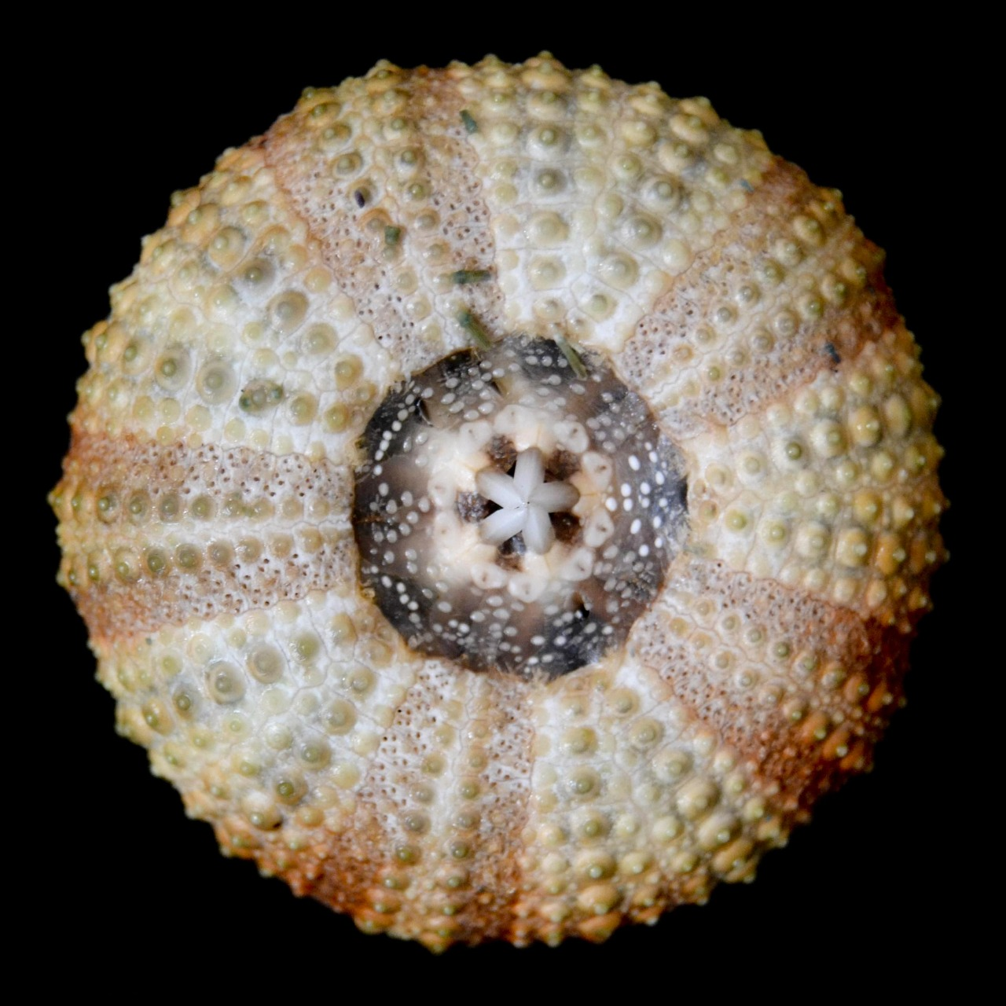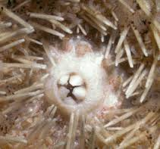

A B

a) Qual é a estrutura indicada pela seta A? ______________________________________

b) Como se denomina a estrutura indicada pela seta B? Para que ela serve?

________________________________________________________________________________________________________________________________________________________________________________________________________________________________________________________________________________________________________

c) Por que o animal acima foi classificado como equinoderma?

____________________________________________________________________________________________________________________________________________________

**7)** Os equinodermas podem ser venenosos. Quais são as estruturas utilizadas por eles para injetarem o seu veneno?

____________________________________________________________________________________________________________________________________________________

**8)** Relacione as colunas:

Classes de equinodermas Representantes

1. Echinoidea ( ) Serpente-do-mar
2. Asteroidea ( ) Pepino-do- mar
3. Crinoidea ( ) Lírio-do-mar
4. Holothuroidea ( ) Estrela-do-mar
5. Ophiuroidea ( ) Ouriço‐do-mar

**9)** Escreva o tipo de simetria existente nos animais representados abaixo:



  