 3º ano EM

1. Read the text below .

## Arts

# Zoom Shabbat, drive-through confessional: Faith during coronavirus

SaveSharePrint

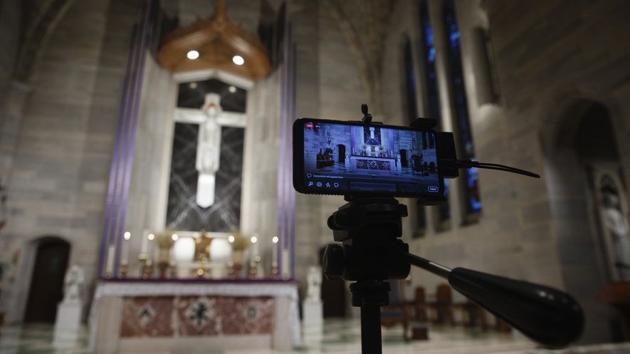A phone is used to livestream a Eucharistic Adoration service at Saint Ann Catholic Church in Washington, D.C., on March 29, 2020. The Archdiocese of Washington has temporarily halted all public Masses and gatherings in an effort to contain the spread of the coronavirus. Photo: Carolyn Kaster/AP Photo

By Christian Science Monitor, adapted by Newsela staff

Published:04/13/2020

Word Count:986

Father Corey Bassett-Tirrell was shocked to see the line of cars in the parking lot of St. Mary's Church in Chelmsford, Massachusetts. They waited to participate in the church's first-ever drive-through confessional.

Catholics practice the tradition of confession. Confession is admitting one's sins to the church's priest. By doing so, people receive forgiveness and a blessing.

The coronavirus, or COVID-19, has forced many religious communities to stop physical gatherings for prayer and worship.

Bassett-Tirrell sat on a chair surrounded by orange traffic cones to keep cars at a safe distance. From there, the priest offered the chance for drive-through confession. Seventeen people came in two hours.

Like many places of worship across the United States, the two Roman Catholic churches in Boston, Massachusetts, have suspended all physical gatherings. This includes the celebration of the Mass. Mass is the central act of worship for Catholics.

Bassett-Tirrell's church is prepared to livestream regular worship services. It already had social media options for those unable to attend in person. Still, Bassett-Tirrell says these technologies are not substitutes for some essential traditions of Catholic worship. Many traditions require people to be present.

"But I see this as a great opportunity — though a difficult one," says Bassett-Tirrell, who became a priest last year.

"My prayer is that people will come back to the altar at a time when it's safe again, and have a deeper understanding," he says.

The United States is in the midst of a new era of social distancing. The coronavirus has stopped community gatherings across the country. In following these guidelines, communities of worship, including mosques for Muslims and synagogues for Jews, have been forced to find other forms of gatherings for traditional worship.

The vast majority have turned to technology. They are using interactive teleconferenced gatherings, livestreamed services and even old-fashioned conference calls.

For many, though, the absence of community and physical traditions have presented important questions about religion and spirituality.

## If It's Online, Is It Jumu'ah?

"To suspend the Friday prayer, to suspend an obligation that has been made quite clear in the Scripture, is quite serious," says Selaedin Maksut. He is a religious scholar in New Jersey and works on the Council on American-Islamic Relations. Friday prayer services are part of the social rhythms of American Muslim communities. They're a time and place to gather to discuss politics, business and other aspects of life.

The week of March 16, as the seriousness of the coronavirus began to unfold in the United States, Muslim communities throughout New York and New Jersey were "pulling their hair out," Maksut says. The community tried to decide on March 19 whether or not to cancel prayer services.

The primary day of worship for Muslims is called Jumu'ah. It is a religious requirement for all adult Muslim men.

"The conversation was, well, how about we just have the sermon on Facebook so everyone can observe from home?" said Maksut.

Maksut said a group of scholars decided the tradition of Jumu'ah must be with other people. Thus, an online sermon would not qualify. The importance of Jumu'ah comes from the physical gathering of people.

"You might be listening at home, but you're really not participating in the essential physical, collective and group effort," Maksut said of the idea of an online Jumu'ah sermon.

Still, in the Muslim religion, Maksut and others say the preservation of human life is more important than all other religious obligations.

## Shabbat Via Zoom

On March 20, the synagogue Temple Beth O'r Beth Torah in New Jersey welcomed Shabbat. They gathered for the Jewish worship service using the video technology of Zoom. Shabbat is the day of rest in the Jewish religion. It starts on Friday at sunset and continues until the following evening.

"People are just trying to get accustomed to the technology," said the synagogue's Steven Stern. He's also planning group meetings on Zoom to discuss religion.

"We're hoping to combine elements of the service together with an opportunity where we can actually see each other and hear each other, ask questions and answer questions, and to really, in that way, connect and feel part of the community," Stern says.

Coronavirus has thrust questions about religion and the nature of community in the digital age into regular conversation, says the Reverend Paul Brandeis Raushenbush. He is a Baptist minister. Raushenbush has spent a significant part of his nearly 25-year career involved with online church communities.

"The truth is, we are in touch with one another much more because of technology than we were before, not less," he says. "My Facebook page feels like a prayer circle, and people are reaching out to one another and people are showing up for one another in new and unprecedented ways that are allowing for a sense of deep community."

## On This Virtual Rock

On March 22, Raushenbush helped lead a church gathering using the virtual environment Altspace. Using avatars in a virtual grass field, the virtual minister led people in a guided 10-minute meditation. Then he asked them to gather with him on a large rock in the field.

He asked how they were holding up. As many of those gathered responded, others could virtually express their emotions with "emoticons." Some released hearts that bubbled above their heads to express their connection to the speaker's words.

"We can actually say things to one another and show up for one another in ways that can be deeply loving, and show our vulnerability and be present to one another in a way that sometimes face-to-face meetings do not allow," says Raushenbush.

Something similar happened at the drive-through confessional in St. Mary's parking lot. Bassett-Tirrell said that some people who stopped by told him they were less intimidated to come to confession in their cars.

Still, many are longing for the time when they can return to the forms of worship that are central to the faith.

<https://newsela.com/read/faith-during-coronavirus/id/2001007583/?utm_source=aotd&utm_medium=email&utm_campaign=test-1&utm_content=news-1>

1. Use at least 120 words to write what you understood about the text above:

____________________________________________________________________________________________________________________________________________________________________________________________________________________________________________________________________________________________________________________________________________________________________________________________________________________________________________________________________________________________________________________________________________________________________________________________________________________________________________________________________________________________________________