|  |  |
| --- | --- |
|  | **EXERCÍCIO DE INGLES**  **Nome:_______________________________________**  **PROFESSORA: Helga Nelken 2º ano EM**  **Data de entrega : 11/06** |

## Read the text then do the **writing** at the bottom at the page:

## World History

# The 1918 flu pandemic that killed millions

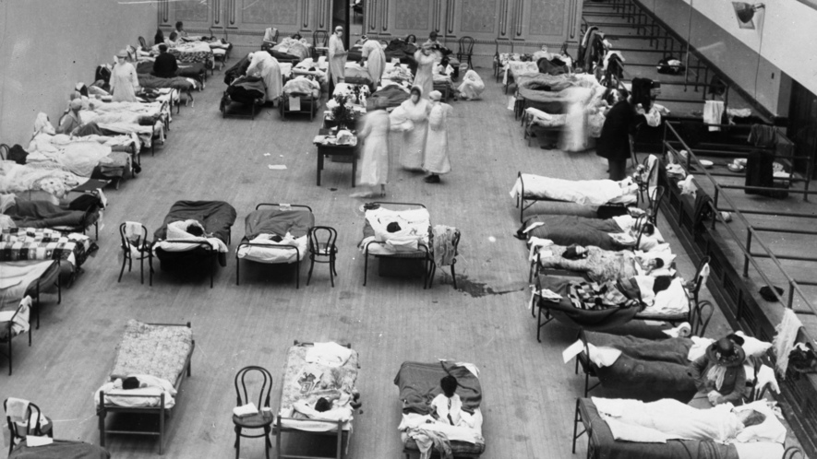Image 1. American Red Cross nurses tend to flu patients in temporary wards in Oakland, California, 1918. Photo by: Edward A. "Doc" Rogers. From the Joseph R. Knowland collection at the Oakland History Room, Oakland Public Library.

By History.com, adapted by Newsela staff

Published:12/18/2017

Word Count:908

Recommended for:Middle School - High School

Text Level:7

The influenza or flu pandemic of 1918 to 1919 was the deadliest in modern history. It infected an estimated 500 million people worldwide – about one-third of the planet's population at the time. It killed an estimated 20 million to 50 million victims. More than 25 percent of the U.S. population became sick, and some 675,000 died.

The 1918 flu was first observed in Europe, the United States, and parts of Asia before swiftly spreading around the world. Surprisingly, many victims were young, otherwise healthy adults. At the time, there were no effective drugs or vaccines to treat this killer flu strain or prevent its spread. In the U.S., citizens were ordered to wear masks. Schools, theaters and other public places were closed. Researchers later discovered what made the 1918 pandemic so deadly: The influenza virus invaded victims' lungs and caused pneumonia.

## Flu facts

The flu is a virus that attacks the respiratory system. The primary organs of the respiratory system are the lungs. The virus is highly contagious. When an infected person coughs, sneezes, or talks, respiratory droplets are generated and transmitted into the air. Someone nearby who inhales these droplets can become infected. Even a person who touches something with the virus on it and then touches his or her mouth, eyes, or nose can become infected.

Flu outbreaks happen every year. How severe they are depend in part on the type of flu virus spreading. Usually about 200,000 Americans a year are hospitalized for flu-related complications. These include pneumonia, ear and sinus infections, and bronchitis.  Over the last three decades, between 3,000 and 49,000 people a year have died because of the flu. Some people face a higher risk of getting sick, including young children, people over age 65, and pregnant women, as well as people with certain medical conditions, such as asthma, diabetes, or heart disease. A flu pandemic, such as the one in 1918, occurs when an especially powerful new influenza strain appears and spreads to many people across a wide geographic area.

## The flu strikes far and wide

The first wave of the 1918 pandemic occurred in the spring and was generally mild. The sick, who experienced typical symptoms as chills, fever, and fatigue, usually recovered after several days. Not many died. However, a second, highly contagious wave of influenza appeared in the fall of that same year. Victims died within hours or days of their symptoms appearing. Their skin turned blue and their lungs filled with fluid, causing them to suffocate.

It's unknown exactly where the 1918 flu virus came from. It became known as the "Spanish Flu" because Spain was one of the earliest countries to be hit hard by the disease.

One unusual aspect of the 1918 flu was that it affected so many young men and women who were otherwise healthy. This is a group that is not usually affected by the flu. In fact, according to journalist Gina Kolata, more U.S. soldiers died from the 1918 flu than died in battle during World War I (1914-1918).

Although the death toll of the 1918 flu is estimated at 20 million to 50 million victims worldwide, other estimates run as high as 100 million. The exact numbers are impossible to know due to a lack of medical record-keeping in many places.

## Fighting the flu

When the 1918 flu hit, doctors and scientists didn't know what caused it or how to treat it. Unlike today, they had no effective vaccines or antiviral drugs.

World War I had left parts of America with fewer doctors and nurses than in the past. Many of them came down with the flu themselves. In some areas, hospitals were so crowded with flu patients that schools and private homes had to be converted into makeshift hospitals, staffed by medical students.

Officials in some communities quarantined the sick. They ordered citizens to wear masks and even banned spitting. They shut down public places, including schools, churches and theaters. People were advised to avoid shaking hands and to stay indoors.

## The flu takes a heavy toll on society

The flu pandemic wiped out entire families.

It harmed every aspect of society, including the economy. In the U.S., businesses had to shut down because so many employees were sick. Basic services such as mail delivery and garbage collection were affected. In some places there weren't enough farm workers to harvest crops.

## Flu pandemic finally ends

Image 2. Dr. Terrence Tumpey studies a reconstructed version of the 1918 flu at the Centers for Disease Control and Prevention in 2005. Photo: CDC Public Health Image Library. [click to expand]

By the summer of 1919, the flu pandemic came to an end. Infected people had either developed immunity or died. Almost 90 years later, in 2008, researchers announced they'd discovered why the 1918 flu was so deadly. It was a group of three genes in the virus that weakened a victim's bronchial tubes and lungs. This made it easy for the flu victims to develop pneumonia. Pneumonia is a lung infection that inflames the lungs and air sacs, causing them to fill with fluid. Pneumonia can make you very sick.

Since 1918, there have been several other influenza pandemics, although none as deadly. One outbreak from 1968 to 1969 killed approximately 1 million people, including some 34,000 Americans. More than 12,000 Americans died during the H1N1 (or "swine flu") pandemic that occurred from 2009 to 2010.

<https://newsela.com/read/lib-history-flu-pandemic-1918/id/38472/?collection_id=2000000398>

1. Use approximately 150 words to write about what you have just read.: