|  |  |
| --- | --- |
|  | **EXERCÌCIO DE INGLES**  **Nome:_______________________________________**  **PROFESSORA: Helga Nelken 8º ano** |

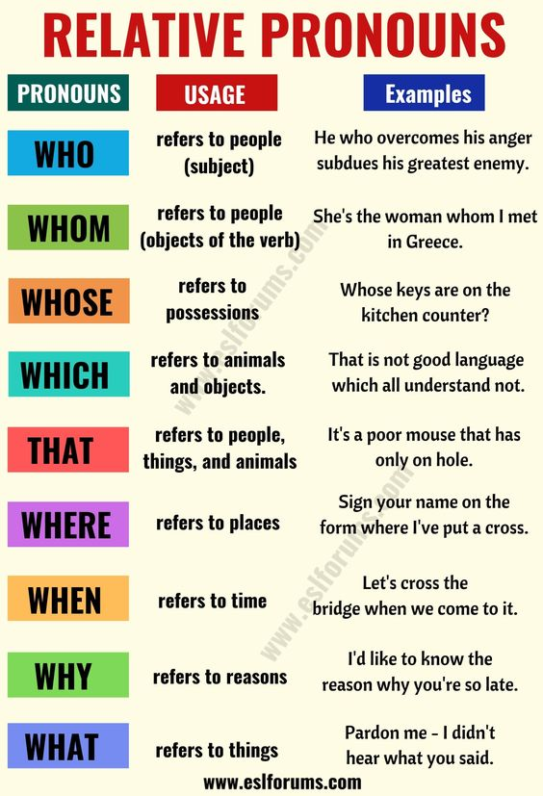

1. Ask questions and answer them using all the WHs above.