- Read the numbers.
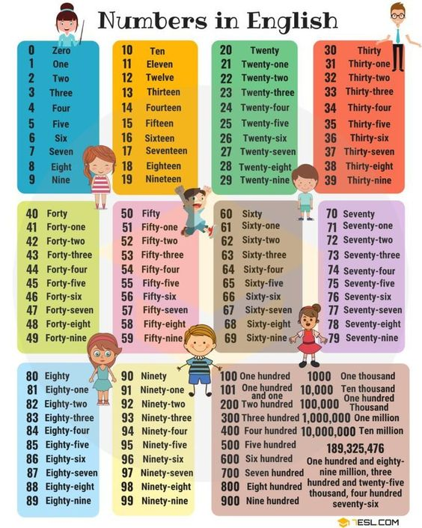
- Write the numbers :
- What is the date of your birthday ? _______________________________

- How old is your mommy ? ______________________________________

- How many friends do you have ? _________________________________

- What is your favorite number ? __________________________________

