|  |  |
| --- | --- |
|  | **EXERCÍCIO DE INGLES**  **Nome:_______________________________________**  **PROFESSORA: Helga Nelken 4º e 5ºanos** |

Este é o material que utilizaremos na aula de 4 de agosto. Se você quiser fazer a atividade antes da aula, fique à vontade !

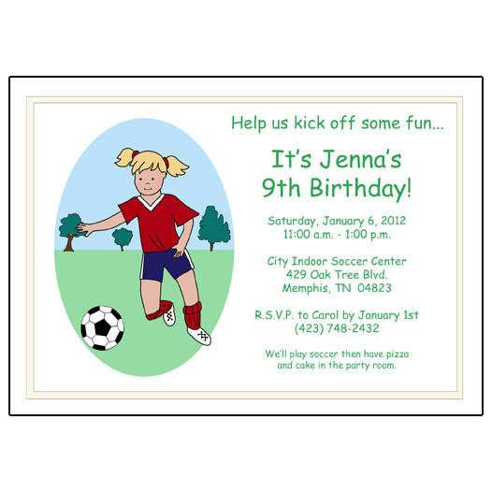

<https://www.mandysmoon.com/products/soccer-player-birthday-party-invitations-girl>

1. By looking at the picture, one can realize that it is :
2. A wedding invitation
3. A camping trip
4. An anniversary
5. An invitation to a party
6. The guest(s ) used the word “ kick off “ to convey:
7. The idea of playing ball and having fun
8. The idea of eating pizza
9. The idea of having cake at the party
10. The idea of helping the others