 4º / 5 º anos

1. Write the names of the parts of the house.

KITCHEN / BEDROOM / LIVING ROOM /

BATHROOM / GARAGE / DINING ROOM

1 2

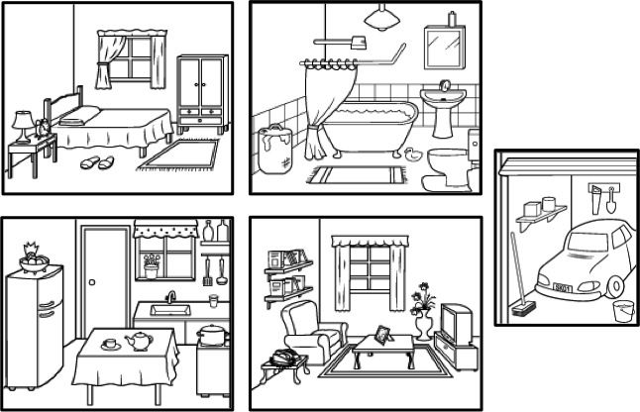

3 4

1) _________________________________________

1. _____________________________________________
2. _____________________________________________
3. _____________________________________________

2) Answer the questions about your house / apartment :

1. Do you live in a house or apartment ?

­­­­­­­­­­­­­­­­­­­­_______________________________________________________

1. Is it big or small ?

________________________________________________________

1. How many bedrooms are there in your house / apartment ?

________________________________________________________

1. What color is the bathroom ?

________________________________________________________

1. Do you like your bedroom ?

________________________________________________________