**Lista de Exercícios - Semelhança de Triângulos - 9° ano**

[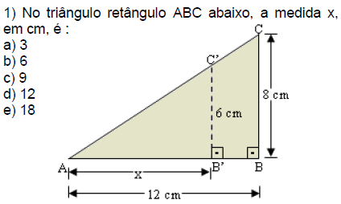](http://2.bp.blogspot.com/-XovoZzQ4g5Y/VfS5RwNvO3I/AAAAAAAAGac/DiyncCfV3Dk/s1600/s1.PNG)

[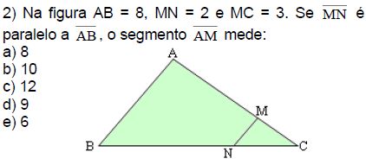](http://2.bp.blogspot.com/-P4-ik_IlXMg/VfS5R870cxI/AAAAAAAAGaY/mta3idMggWI/s1600/s2.PNG)

[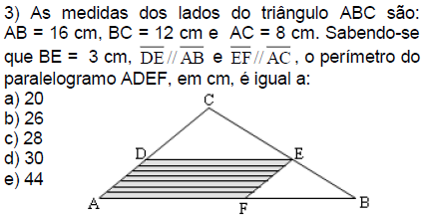](http://1.bp.blogspot.com/-JXOPpjokhaQ/VfS5R5pHfHI/AAAAAAAAGaU/TQk5JyuLGUM/s1600/s3.PNG)

[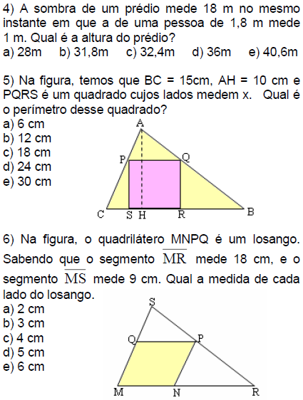](http://1.bp.blogspot.com/-oJdUVSgJEDw/VfS5SIIJJCI/AAAAAAAAGak/o8xMH_2JE0o/s1600/s4.PNG)

[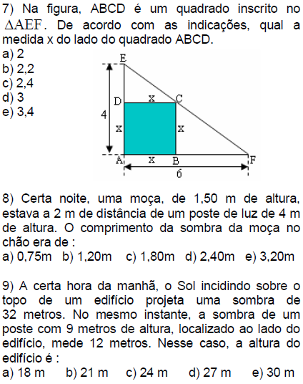](http://4.bp.blogspot.com/-Sp48S0R2RzE/VfS5SUS0mTI/AAAAAAAAGao/XQw-7xanqL0/s1600/s5.PNG)

[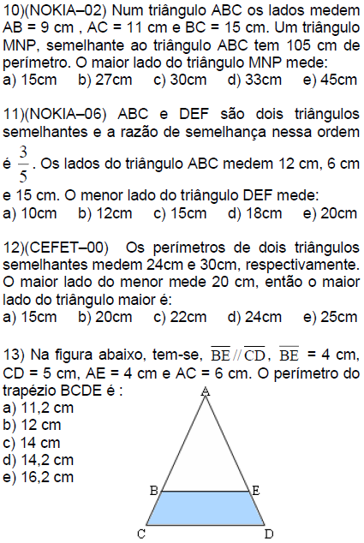](http://3.bp.blogspot.com/-bq86erxOIxc/VfS5SYRk4YI/AAAAAAAAGaw/uq8z5PIz9Fk/s1600/s6.PNG)

[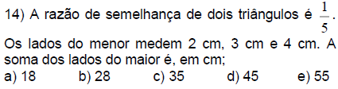](http://3.bp.blogspot.com/-TFc-ZMqmitc/VfS5SsLe2HI/AAAAAAAAGa4/BnkPdcmsFC4/s1600/s7.PNG)

[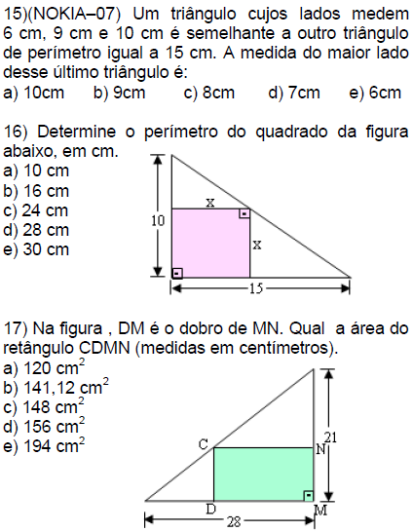](http://2.bp.blogspot.com/-2ePRsptLj94/VfS6198HxmI/AAAAAAAAGcU/ihyICLjk6ww/s1600/s8.PNG)

[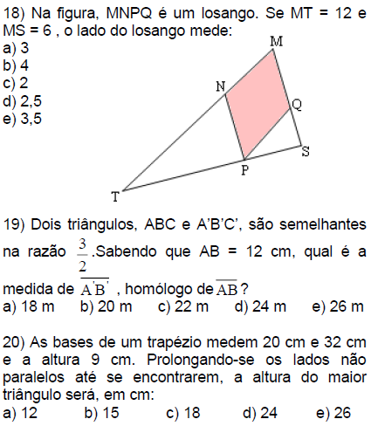](http://2.bp.blogspot.com/-J0DmRtGfIjc/VfS6135eX4I/AAAAAAAAGcg/-AyAa07KMAQ/s1600/s9.PNG)

[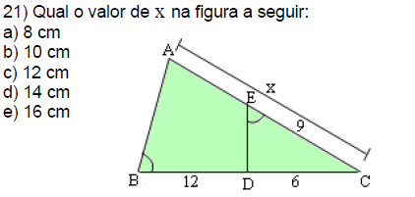](http://1.bp.blogspot.com/-D-lHnvnN0_w/VfS6z6YDu-I/AAAAAAAAGbQ/yjU0KJ2_WZY/s1600/s10.PNG)

[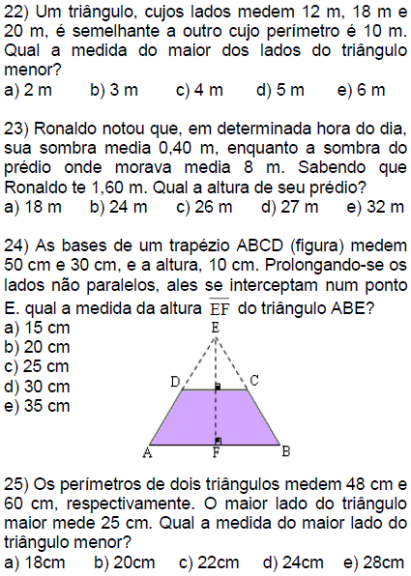](http://1.bp.blogspot.com/-dvzgDKYITRI/VfS60IDLf7I/AAAAAAAAGbo/MBxEuq3oU2g/s1600/s11.PNG)

[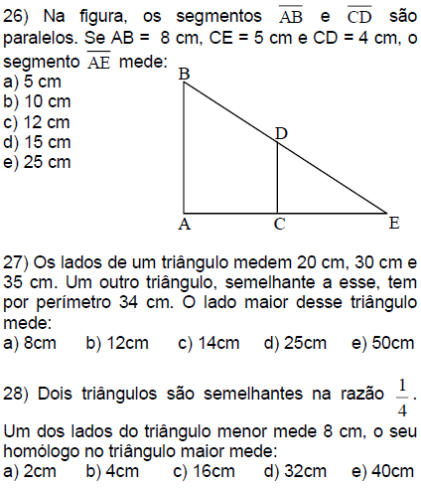](http://3.bp.blogspot.com/-sQho3jizs2I/VfS60KRc7zI/AAAAAAAAGbU/6fCgYDalrLs/s1600/s13.PNG)

[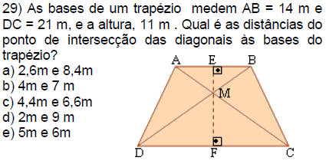](http://2.bp.blogspot.com/-XQXgKxmgC6U/VfS60bXXyOI/AAAAAAAAGbk/hk5Z-zrK3w4/s1600/s14.PNG)

[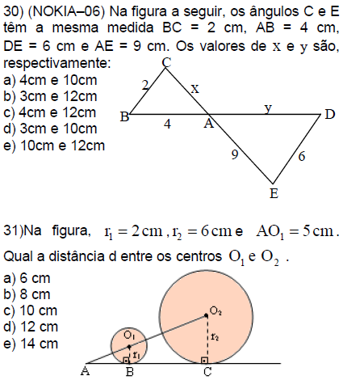](http://3.bp.blogspot.com/-WT-x65hOAII/VfS60pd_6rI/AAAAAAAAGbg/bZ0m8Sd8Q7k/s1600/s15.PNG)

[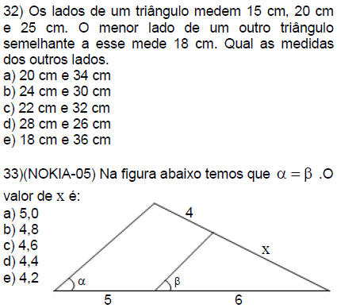](http://1.bp.blogspot.com/-12zdqozXbTw/VfS61EHOJKI/AAAAAAAAGbw/egqmW-K8NzE/s1600/s16.PNG)

[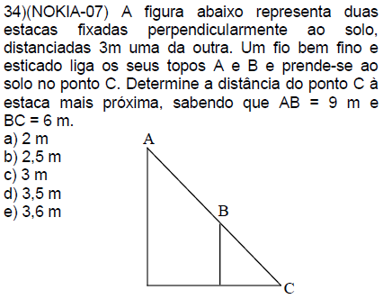](http://3.bp.blogspot.com/-87V8oE-hXPE/VfS61DxUFoI/AAAAAAAAGcA/fl5-51XGkWI/s1600/s17.PNG)

[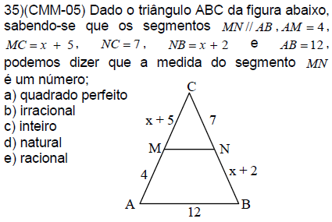](http://2.bp.blogspot.com/-eBtvImWgghc/VfS61QDU7RI/AAAAAAAAGcM/U-u982kmnu0/s1600/s18.PNG)

[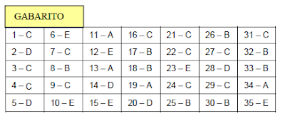](https://3.bp.blogspot.com/-uDK2UZ9PW3o/WXZhJYh4InI/AAAAAAAAPlU/Wc4HT1ItWb4EeSmw5KwXMsRSp_Yv2oVtgCLcBGAs/s1600/GABA.PNG)